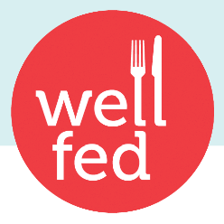

- Meals are made in-house from scratch using whole and wherever possible, locally sourced ingredients.
- We are proud to let you know that all of our chicken is antibiotic and hormone free.
- Our menu meets the guidelines for Food and Beverage Sales in BC schools, but we don’t stop there. We look for ways to add nutrient-rich ingredients and essential lean protein that will give your kids the staying power to learn eﬀectively. We use a balance of ingredients not just starches. For more details just take a look at our ingredient list.
- No deep frying here! We are passionate about creating healthy eating habits to last a lifetime. Healthy everyday entrées the kids will love to eat and the parents are happy to serve. It’s a win/win.
- Appropriate meal sizes based on age and/or appetite. We oﬀer a regular size for the little guys, or light eaters and a large size for the older kids, or those with a bigger appetite.
- Extensive, delicious baked goods program, made in-house. Even with our baked goods we look for ways to boost the nutrition. We do this by adding whole milk, whole wheat ﬂour, oats and real fruit and vegetables.
- Just want the treats or our new side dishes? You can order those on their own for special school events, or as a lunch day add-on.
- Looking for a vendor you can trust to properly execute an extra theme day/special event? We
can work with you to tailor-make a special menu or theme day/special event at your school, such as Mexican Day or Pasta Day.
- We are highly organized and deliver on time, making execution at your end easier! We even provide extra lunches on us, just in case.
- Our packaging is 100% recyclable and/or compostable.

- Extra fundraising opportunities–Contact us for more information.

